***BarCode***

***Introduction to Barcode***

***A barcode is an image that consists of a series of parallel black and white bars that can be read by a barcode scanner.***

## *A barcode is a square or rectangular image consisting of a series of parallel black lines and white spaces of varying widths that can be read by a scanner. Barcodes are applied to products as a means of quick identification.*

***Barcodes are applied to products to quickly identify them.***

***Barcodes are typically used in retail stores as a part of the purchasing process, in warehouses to track and manage inventory and on invoices to help with accounting.***

***A bar code is an optical and machine-readable form of data used to identify objects.***

***A bar code allows a machine to retrieve a great deal of information about an object as soon as the object is identified through a unique visual code format created by drawing adjacent lines with variable widths and spaces.***

***Bar codes were originally linear, one-dimensional representations of objects.***

***and, advanced two-dimensional data representations appeared in forms like dots, rectangles and other two-dimensional geometric shapes. In upcoming sections we will discuss in great regarding 1D and 2D barcode***

## *A barcode is a visual, machine-readable representation of data; the data usually describes something about the object that carries the barcode. It can be retail store items, identification cards, and postal mail to identify a particular product number, person, or location.*

## *The*barcode*become exclusive and global and can be identified all over the world.*

## *The Barcoding is a universal view today. It helps particular device description over using universal symbols and numbering system, it supports quality image and would permit up to date and detailed occupation of product knowledge. This would product in broad ranging assets combining lowering of supply costs, lower comprehensive number of costs*

## *Types of barcodes*

***There are two types of barcodes: 1-dimensional (1D) and 2-dimensional (2D).***

***1) One dimentional barcodes : are a series of lines used to store text information, such as product type, size, and color. They appear in the top part of universal product codes (UPCs) used on product packaging, to help track packages through the U.S. Postal Service, as well as in ISBN numbers on the back of books.***

***These are the first generation of barcodes and store information by using vertical black and white lines of varying length and thickness. ISBN, UPC, EAN, and Code 39 codes are all one-dimensional barcodes.***

***These series of black and white bars that can store information like a product’s type, size and color. You can find 1D barcodes on the top of universal product codes (UPCs) of a product’s packaging. This helps track packages through package delivery service providers like UPS and FedEx, the US Postal Service and Canada Post.***

***2)Two dimentional barcode are more complex and can include more information than just text, such as the price, quantity, and even an image. For that reason, linear barcode scanners can’t read them, though smartphones and other image scanners will.***

***These codes  codes are typically square and can store more data than 1D codes. QR Code, Aztec Code, Data Matrix, and AR Code are all two-dimensional barcode formats.  
  
 There are plenty of barcode scanners that support 2D barcodes. While not all barcode scanners can read 2D barcodes, Lightspeed Retail POS is compatible with several wireless***[***barcode scanners***](https://retail-support.lightspeedhq.com/hc/en-us/articles/229131008-Supported-hardware)***that support 2D barcodes.***

## *Barcode History*

***The concept for the barcode was developed by Norman Joseph Woodland, who drew a series of lines in the sand to represent Morse code, and Bernard Silver***

***The barcode was invented by Norman Joseph Woodland and Bernard Silver and patented in the US in 1952. Barcodes became commercially successful when they were used to automate supermarket checkout systems.***

***Why we need barcode?***

***Barcodes are mainly used to classify each product uniquely & read it quickly. But why barcodes, we can simply print the unique decimal number on each product***

***The barcode consist of the country code and company code and product code as show in the photos,***

***Country code is which country you belong that country code is assigned to u***

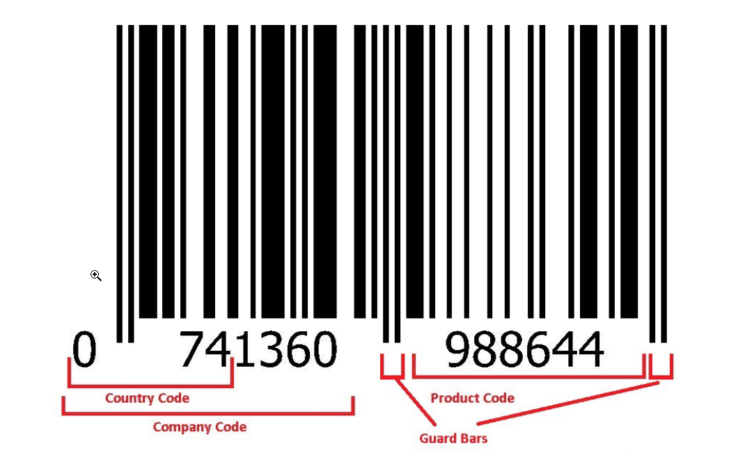

***Company code is unique for your company through the world and product code is unique code like _id for each product***

## *FAQ*

## *What is a barcode?*

***A barcode is an image that consists of a series of parallel black and white bars that can be read by a barcode scanner. Barcodes are applied to products to quickly identify them. Among their many uses, barcodes are typically used in retail stores as a part of the purchasing process, in warehouses to track and manage inventory and on invoices to help with accounting.***

### *What is a barcode scanner?*

***A barcode scanner (also referred to as a barcode reader) is a device that captures and decodes the information contained by a barcode. Traditional barcode scanners consist of the following four components:***

1. ***Light source: This helps the barcode read and accurately decode the information contained in a barcode.***
2. ***Lens: This scans the barcode.***
3. ***Photoconductor: This translates optical impulses into electrical ones.***

***Decoder: This analyzes the barcode’s data and sends it to the scanner’s output port.***

1. ***After capturing the information, barcode scanners link to a host computer or tablet and transmit that information in real-time, without additional human intervention. This helps retailers automate data collection processes and reduce human errors like inventory tracking and processing point of sale transactions.***

## *How do barcodes work?*

***In a nutshell, a barcode is a way to encode information into a visual pattern (those black lines and white spaces) that a machine (a barcode scanner) can read.***

***The combination of black and white bars (also referred to as elements) represents varying text characters that follow a pre-established algorithm for that barcode (more on the types of barcodes later). A barcode scanner will read this pattern of black and white bars and translate them into a line of test that your***[***retail point of sale system***](https://www.lightspeedhq.com/pos/retail/)***can understand.***

## *The benefits of using barcodes*

***While barcodes were originally developed to speed up the sales and transaction process, they come with several other benefits.***

### *Improved accuracy*

***Using a barcode to process a product’s data is much more accurate than having a sales associate manually enter that data, which is prone to human error.***

### *Real-time data*

***Because of the speed at which the information is processed, data about inventory levels or sales is available immediately.***

### *Reduced training requirements*

***Thanks to a barcode scanner’s ease of use (just point and click), employees don’t need much training on how to use one.***

### *Better inventory management*

***With improved accuracy and real-time data, retailers benefit from faster cycle counts and more accurate inventory turnover estimations.***

### *Low cost of implementation*

[***Generating barcodes***](https://www.lightspeedhq.com/resources/retail/barcode-generator/)***is quick and simple, plus, the potential savings thanks to improved transaction speed, as well as the improved accuracy of inventory and sales data, retailers can anticipate savings post-implementation***

## *Business Benefits*

***Barcodes were developed to improve the speed of sales transactions, but there are other potential benefits to businesses, including:***

* ***Better accuracy - Relying on a barcode to process data is far more accurate than relying on manually-entered data, which is prone to errors.***
* ***Data is immediately available - Because of the processing speed, information about inventory levels or sales is available in real time***
* ***Reduced training requirements - Thanks to the simplicity of the barcode scanner, employees need little in the way of training in how to use it. Additionally, thanks to barcodes, there is much less for employees to have to learn and retain.***
* ***Improved inventory control - Being able to scan and track inventory yields a much more accurate count, as well as a better calculation of inventory turn. Companies can hold less inventory when they know how soon they will need it.***

***these is the bar code images , like these it will look***

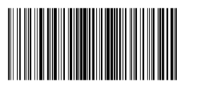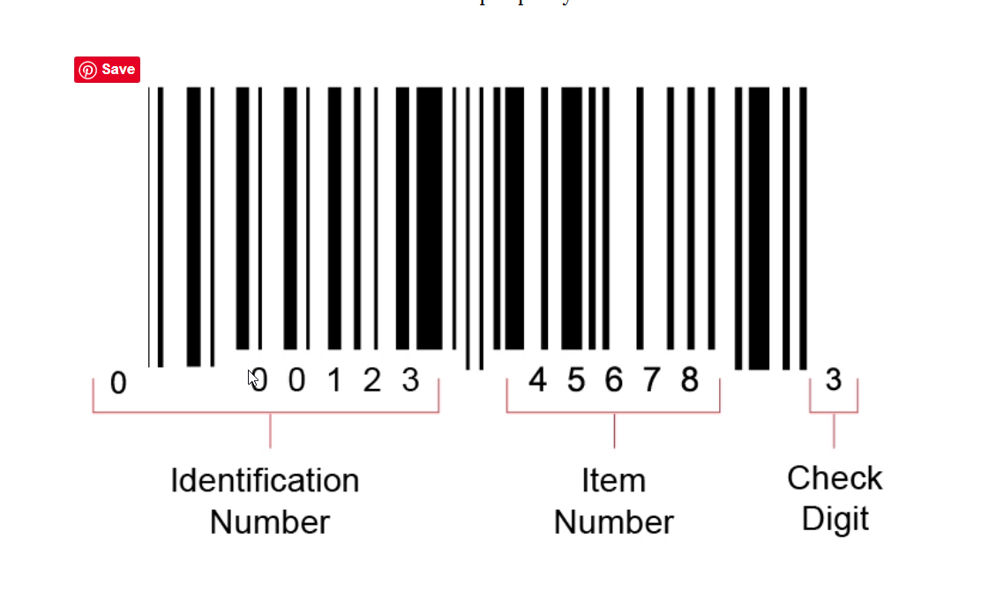 ***here identification number is the country code + company code and item number is the unique no of our product and check no is used for verifying the whether the code is right or wrong   
The main difference between barcodes and QR codes is one of physical dimensions. Barcodes can be scanned in a line. This means that data is limited to what can be placed in that one stretch of stripes. QR codes, on the other hand, add another dimension from which information can be written and scanned.  
  
QR codes can hold more information - While a barcode can represent up to 25 characters, a QR code can go up to 2500. This means you can include much more information, like the URL of a product's page on your webshop. QR codes can be smaller - a QR code can be up to 10 times smaller than a bar code and still readable  
  
QR Code Short Introduction.  
A QR code is a type of barcode that can be read easily by a digital device and which stores information as a series of pixels in a square-shaped grid.  
  
  
  
QR codes also scan faster than linear barcodes. This has to do with the way the information is encoded and the detection pattern in each type of code. One-dimensional barcodes have to be front-and-center in the face of their scanner to be read successfully***

## *BarCode Setup*

## *Get a GS1 Company Prefix*

***Before a company can begin using barcodes, they must first assign the numbers that go inside the barcode, called GS1 Identification Keys. The first step in assigning a GS1 Identification Key is to obtain a GS1 Company Prefix from a GS1 Member Organisation.***

***GS1 Company Prefixes are used by 1.3 million companies worldwide as the basis for creating unique numbers to identify everything in the supply chain.  
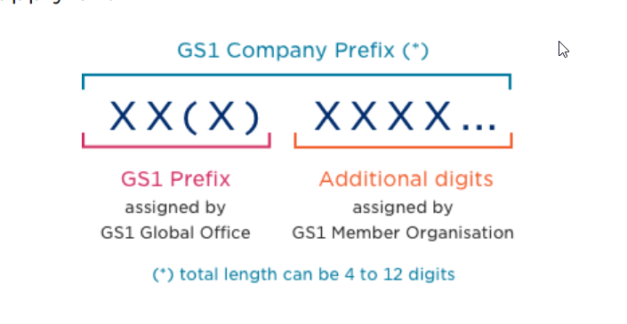***

## *Assign numbers*

***Your local GS1 Member Organisation can provide you with specific information about how many numbers you can assign based on the length of your GS1 Company Prefix.*** 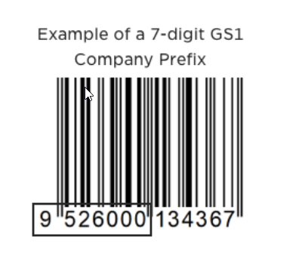

## *Select a barcode printing process*

## *To begin, you should decide what you are barcoding and if the barcode will carry******static******or******dynamic******information inside it. If the information is static (always the same), the barcode can be printed using traditional printing presses directly on the package (e.g., paper milk carton) or on a label that is applied to the package (e.g., label on a gallon milk jug.) If the information is dynamic then either digital or a combination of digital and traditional printing will be required. Select a "primary" scanning environment*

## *The specifications for barcode type, size, placement, and quality all depend on where the barcode will be scanned. By knowing where your barcode will be scanned you can establish the right specifications for its production. Select a barcode*

* ***If you need to barcode a trade item that will be scanned at the retail point-of-sale (POS), the first symbol of choice is the EAN/UPC symbol. This symbol is guaranteed to be scanned by POS systems all over the world. In some cases, the use of GS1 DataBar or GS1 standardised 2D symbols may apply.***
* ***If you are printing a barcode with variable information like serial numbers, expiry dates, or measures, then you will use GS1-128, GS1 DataBar, or GS1 standardised 2D symbols.***

## *Pick a barcode size*

##### ***Symbol sizes***

***The X-dimension is the specified width of the narrowest element of a barcode. X-dimensions are used together with the symbol heights to specify the permissible symbol sizes.***

##### ***EAN/UPC symbols***

***EAN/UPC Symbols are designed for scanning by retail omnidirectional scanners. This means that EAN/UPC Symbols have two segments which are taller than they are wide***

## *Format the barcode text*

***The text typically beneath a barcode, called Human Readable Interpretation (HRI), is important because if the barcode is damaged or of poor quality to begin with, then the text is used as a back-up.*** 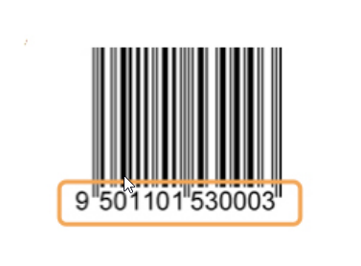

## *Pick a barcode colour*

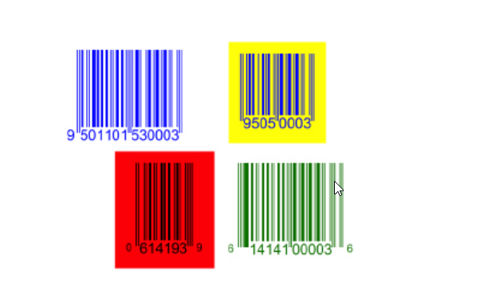

***We can pick the barcode color also as shown in the abave photo***

## *Pick the barcode placement*

***When assigning symbol placement first the packaging process should be considered. You should consult the packaging engineer to make sure the symbol will not be obscured or damaged (e.g., over a carton edge, beneath a carton fold, beneath a package flap, or covered by another packaging layer).***

## *Build a barcode quality plan*

***ISO/IEC 15416 Barcode Print Quality Test Specifications for Linear Symbols and ISO/IEC 15415 Barcode Print Quality Test Specifications for 2D Symbols describes methods for assessing the quality of barcode symbols after they are printed. An ISO-based verifier looks at the symbol in the way a scanner does but goes further by grading the symbol's quality.***

# *Barcode Registration ?*

***The* Barcode Registration*is the development of universal business and industry, plain sound information about products and services wish to be changed by recognition rules that are valid in all trade and management zones in*Chennai*.***

***The barcode registration is a structure has been advanced to meet this right by preparing results that certificates, exclusive and obvious description. The*Barcode*is to be used in wholesalers, retailers and manufacturers use this scheme to interact data between the goods and services they market with***[***barcode registration in chennai***](http://www.solubilis.in/barcode-registration-chennai.php)***. The barcode symbols represent these unique identification numbers by the bar***

***.***

***The required information at all points of the supply chain enables popular and exact data is to be captured during the system of*barcode registration*. The major concepts of this structure is that any information like product or service upon which there is a use to save predefined reports and that may be ordered or estimated at any mark of a supply chain is to be designated a unique identification number or (GTIN) Global Trade Item Number***

***.***

***QR code***

***QR codes are a way of storing data in the form of computer understandable format, that can be scanned by using QR code scanner to retrieve the data. These are widely used nowadays for cashless and UPI payment services. They can be used in case of identifications and are also used for sharing photos, videos and other files***

***How QR code works in Phonepay and Google pay***

## *Qr codelis basically information stored in code. You use a qr code and can read the information, same like any payment /wallet provider. This then points you to the merchant name, you confirm and put the amount and he gets paid. Obviously for the same qr code to work, merchant needs to be registered on all the payment apps you may have. Many countries even visiting cards are qr code, so you scan the qr code and it takes you to the guys personal website, or shows his contact details(no need to exchange visiting cards anymore)*

***QR code is short for Quick Response code. It’s a two-dimensional barcode that contains information like contact details, a website link, payment information and more. For users, it’s a faster and more streamlined experience than typing in a website URL because all they have to do to access the contained information is scan it.***

## *QR code payment*

***A QR code payment works exactly the same way as a ‘normal’ QR code, except when a user scans the code, it brings them to a web payment form. It essentially functions like a POS terminal – customers scan a code with their smartphones and complete the payment on the spot.***

***For businesses, QR code payments represent a compelling way to process payments without having to invest in extra hardware – simply set up QR code payments on your smartphone and you’re ready to go.***

## *QR code payments work*

***When a customer scans a QR code with their smartphone, a notification pops up with a link. The customer clicks the link which takes them to a website, online menu or – in the case of payments – a web payments form.***

***When you’re processing payments with emerchantpay, you can configure your web payment form however you want. It can be seamlessly integrated with your website – so it has the look and feel of your brand, a feature that makes customers feel more secure when paying – and offer any payment methods that suit your business. Customers can pay by entering their credit or debit card details or by selecting any of the alternative payment methods (APMs) we offer, including Apple Pay, PayPal, Alipay, and many more***

***Giving out mobile numbers or billers code may lead to fraud. Using QR codes eliminates this possibility.***

***QR codes are easy to generate and customers don’t need any additional hardware to pay via them. Just a smartphone with a camera is enough.***

***They are similar to barcodes, the difference is, QR codes can store a large amount of data compared to barcodes.***

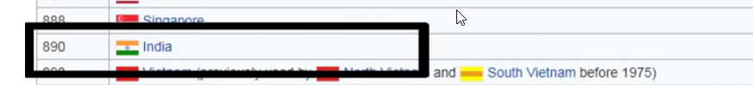

## 

***Here 890 is a country code for the QRCode in the india  
QR codes generally create a sort of pixel pattern with each part containing a piece of information. In the case of digital payments, the information can be, merchants’ details, transaction details, etc.***

***Upon scanning, QR code patterns (horizontal and vertical black patterns on white background) get decoded by the software and get converted into the character string.***

***The Qr codes (for payment acceptance) generally carry commands related to transactions.***

***Merchant can generate QR codes for his shop, or for any fixed or variable amount. According to this command, the QR code is generated. It either opens a payment link, confirms payment, or does any other operation as specified.***

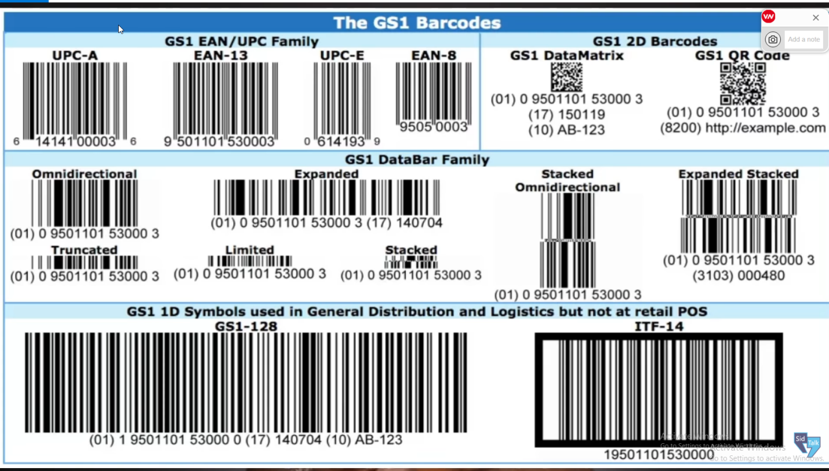

## *Advantages of QR code*

***Although similar to the linear barcodes we see on products in shops, the QR code has four important advantages:***

***It stores a large volume of data.  
It can be scanned from a screen or from a paper.  
It can be read even if part of the code is damaged.  
It’s safer because information can be encrypted.***

***As the QR code is two dimensional, it contains more data than a one-dimensional bar code.***

***QR code can store up to 4,296 alphanumeric characters and unlike a barcode, it is two dimensional, meaning it can be scanned in any direction and thus can contain more information than barcode.***

## *Types of QR Code*

### *Static QR code:*

***Static QR code contains the Payment URL directly placed inside. As these QR codes are static, the content of the codes can not be altered and these codes also can not be tracked.***

***They are used for quick and simple online payment acceptance. Customers just have to scan the QR code, enter the purchase amount, the merchant will verify the details and then the customer can initiate the online payment.***

***We often come across such codes at small shops, at restaurants, hardware stores, medicals, in-store retails, etc.***

### *Dynamic QR code:*

***Dynamic QR code offers a better payment experience for both customers and merchants. It is editable and comes with extra features like password protection, scan analysis, etc.***

***A merchant can find out various details like how many people scanned the code or what type of devices were used for scanning, etc***

***. dynamic QR code conveys the purchase amount and merchant information.***

***In this case, the customer just has to accept the transaction through the QR code application***

***How can Merchants Accept QR Code Payments ?***

***Merchants can accept online payments via QR codes by setting up acceptance/service through payment companies and companies offering processing services via mobile application.***

***With these three simple steps, you can start accepting QR codes Payments quickly:***

***STEP 1:  Download [Lyra EPOS application](https://www.lyra.com/in/best-epos-app/)  
STEP 2: Register Yourself  
STEP 3: Start accepting payments***

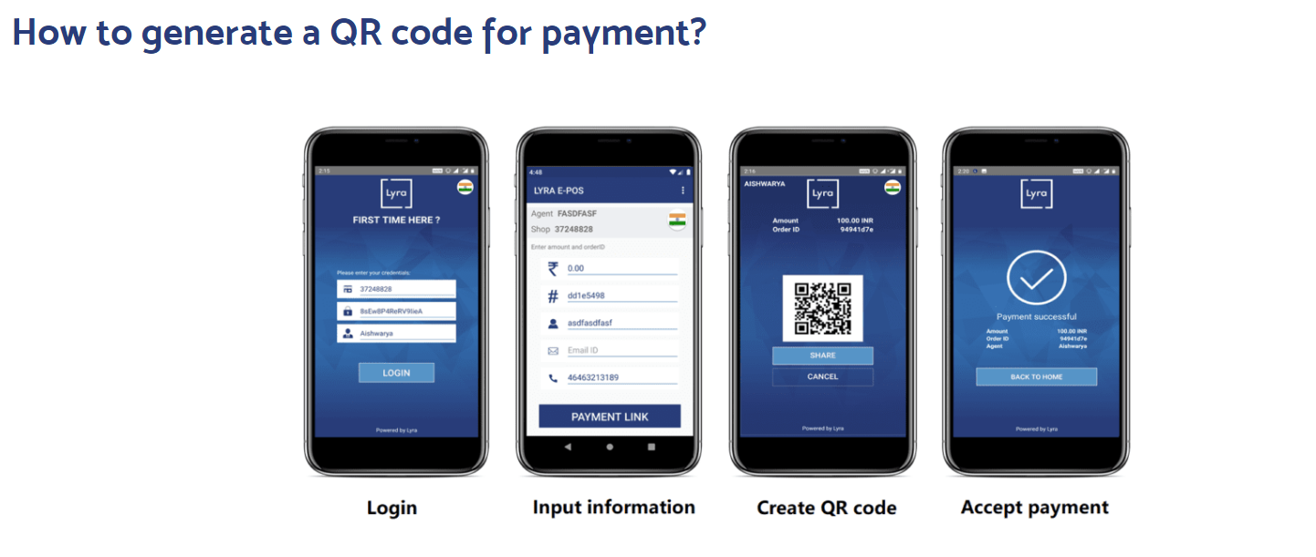

***Some of the barcode and QR code I generated and did lab using npm packages , this source code github url : https://github.com/harishkumarforeverr/BarCode-QR-code***